To: Delaware Department of Transportation (DelDOT)
From: Megan Mucha, University of Delaware Student
Date: December 5, 2018
Subject: Proposal: Add University of Delaware to Exit 104’s Signs on Route 1

The purpose of this proposal is to seek clearance to add University of Delaware to Exit 104’s signs on Route 1. UD’s Dover campus, and by extension its Associate in Arts Program, is currently lacking proper visibility, especially in and around Dover itself. This includes on Route 1, where Exit 104’s signs list Del Tech, Del State, Wesley College, and Wilmington University, but not UD. In fact, no highway signs inform the Dover community of UD’s presence in Kent county. This proposal will provide information about the current visibility of UD’s Dover campus, a possible solution, a research plan, a weekly schedule, and my qualifications to address this problem.

Problem: Lack of UD Signs on Route 1

In 1966, the University of Delaware formed a partnership with the state of Delaware, at the request of the Delaware legislature, and created the University Parallel Program. The program allowed students to complete two years of college in Georgetown at a decreased tuition rate before earning a four-year degree on Newark’s campus. In 1971, the program opened its Wilmington location, and 1985 marked the expansion of this program to the Terry Campus in Dover. In 2005, this program became the UD Associate in Arts Program (AAP), which allows students to earn an Associate’s degree after completing 60 core class credits (“History of the Associate”). According to the AAP Web site, the program continues to grow. However, the AAP has not always seen growth in its enrollment numbers. For example, enrollment fell from 858 in 2013 to 778 in 2015. And Dover’s enrollment is usually under 200 students (“Unduplicated Enrollment”).

Efforts have been made to promote the AAP. For example, the University of Delaware participates in College Application Month and waives the application fee from October to November. UD also attended the Appoquinimink School District’s National College Fair earlier this year (on October 18). While there, students had the opportunity to speak with representatives from UD along with 87 other colleges, universities, military academies, and technical schools. Students could also learn about UD’s various scholarship opportunities, programs, and admissions requirements.

While these efforts to increase the visibility of UD’s Dover campus and AAP, especially to low-income or first generation college students, are admirable, there is more that can be done.

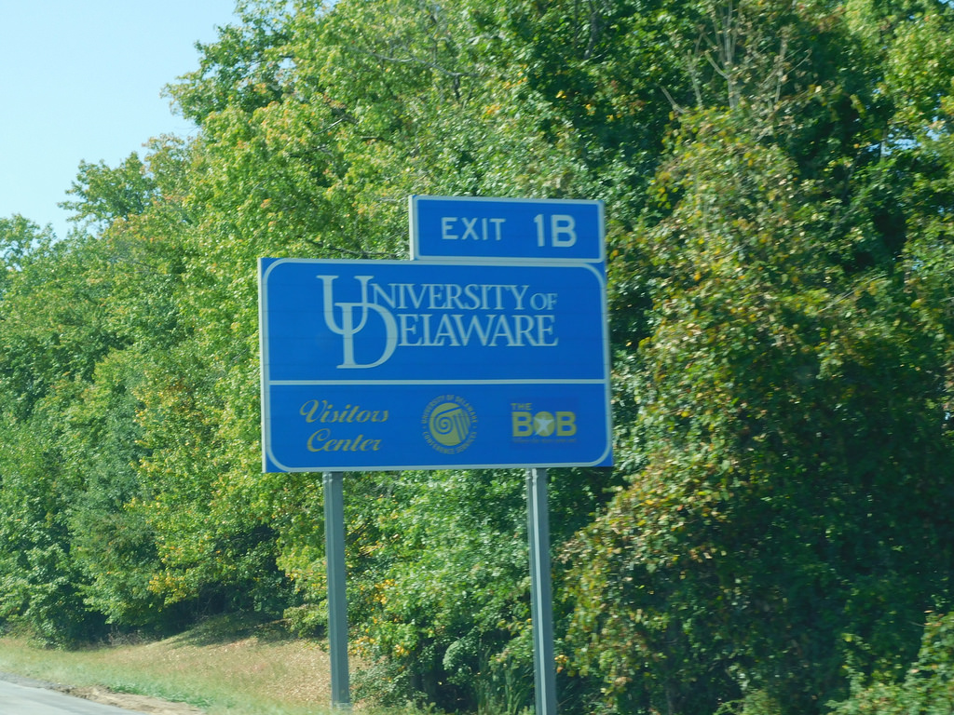
The University of Delaware as a whole only has one highway sign to inform drivers of the main campus’s location. It can be found in Newark, near Exit 1B southbound on Interstate 95. It is a standard blue highway sign that depicts UD’s logo and the exit number. It also alerts drivers to UD’s Visitors Center, Conference Services, and the Bob (Bob Carpenter Center).

The University’s AAP campuses do not have any highway signs. The Terry Campus in Dover is most easily reached off Route 1 after taking Exit 104. However, UD has no sign anywhere near this location. The two signs approximately one half mile before exit 104 (north- and southbound) list Del Tech, Del State, Wesley College, and Wilmington University but exclude UD altogether. Given that UD runs a program on the Terry Campus, it should be listed.

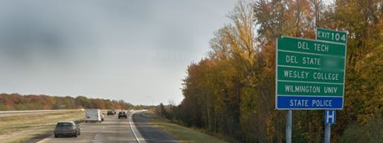

Having a sign on Route 1 would be beneficial to UD’s stakeholders and the state’s residents. Research suggests that an increase in signs leads to an increase in enrollment. For instance, after the University of Kansas installed a highway sign that boasted its academic and athletic achievements, enrollment increased from 28,924 in 2006 to 29,365 in the fall of 2008 and 29,242 in the fall of 2009 (“The University of Kanas”). This sign had their mascot, a Jayhawk, followed by the exit number and three lines about their recent successes (Vierthaler & Allender 2008). It cost $8,000 to create and install.

If more people are made aware of UD’s AAP, then more people will at least apply. If more are accepted, then a higher acceptance rate will result in an increase in tuition for UD. However, increased enrollments to the APP would not only be beneficial monetarily; it would also benefit Delaware as a whole. As of 2017, only 31% of people in the state of Delaware held a 4-year degree (“United States Census Bureau”). Considering the vast number of growing job markets, many of which require some level of higher education, this number really should be higher. By making this kind of education more accessible and our program more visible, we can work to raise these numbers and better the futures of Delawareans.

For these reasons, I propose that University of Delaware be added to Exit 104’s signs on Route 1 to increase the visibility of UD’s Dover campus to the Dover community and Delaware community as a whole.

Research Plan

Research Completed

- To assess feasibility, I emailed both the University of Delaware’s Office of Communications and Marketing (OCM) and the Delaware Department of Transportation (DelDOT). In the emails, I said that I noticed that UD is not listed with the four other universities and colleges on Exit 104’s signs. I asked if they know why this is and what can be done to have UD added.

- While I waited for responses, I located a manual on traffic control devices created by the state of Delaware. I was specifically looking under a section called “Signs” to see what it had to say about signs pertaining to universities. This was to ensure that putting up a sign was legal, and to get a brief overview of any restrictions on design or location.

- I also searched online for any examples of universities outside of UD utilizing highway signs. I looked for answers to questions such as:
  - Which universities, if any, had a highway sign?
  - What was the approximate cost?
  - Was it effective?
One such example I found was the University of Kansas. I analyzed effectiveness by checking UK’s enrollment numbers before and after the sign to see if there was an increase (there was).

- I then checked online to see if UD as a whole had any highway signs for any of its campuses. This would help give a better idea of how to design a new highway sign specifically for UD’s Dover campus. It would also help me locate the ideal place to install a new sign by seeing where current signs were placed relative to the campus it was advertising. I concluded that with Exit 104’s signs would indeed be the best location to inform anyone heading into Dover of the campus’s presence.

Research to be Completed

- Conduct online secondary research: During this part of my research, I plan to use resources provided to me by UD. This includes UD’s library and online databases to look for articles published on outdoor advertising. I will be focusing more specifically on additional examples of advertising for colleges and universities beyond that of UK. I will be looking to answer questions such as:
- What other universities have made use of highway signs?
- How is the effectiveness of outdoor advertising measured?
- Has outdoor advertising been statistically proven to be effective?

- Perform primary research: I will be surveying the students of UD’s Dover campus and main campus. The survey will consist of questions such as:
- If you are in the AAP, how did you learn about it?
- If you are not in the AAP, have you heard about it? How much do you know about the program already?
- If you are not in the AAP, did you apply? If not, would you now (given the chance to switch out)?
- Do you think that a highway sign would increase the visibility of UD’s Dover campus?

- Conduct secondary research on the specific restrictions involved in the creation of a new highway sign using resources provided by the state of Delaware: Brief research has shown that a highway sign informing the public of the location of government-approved institutions, including universities, is allowed to be constructed with a permit. Some more in-depth questions I look to answer include:
- What is the cost of such a permit?
- What logo can be used?
- What are the specifics involving the placement of such a sign?
  - How close to or far from the highway must it be?
- Are there any structures or buildings that it must be a certain distance away from?

- Locate and contact a DelDOT representative (either Yvette Smallwood, Registrar of Regulations, or Bethany Fiske, Assistant Registrar of Regulations) to discuss the specifics of creating a new highway sign: I will be asking questions such as:
  - What is the average cost of a new highway sign (creation and maintenance)?
  - Who is responsible for the maintenance of highway signs?
  - What are the restrictions involved with logo usage on highway signs for universities?

Research Schedule

This weekly schedule I have created ensures that this project can be completed in a timely manner.

Research Completed

Week 1
- Emailed UD’s OCM and DelDOT to assess feasibility
- Located a manual on traffic control devices created by the state of Delaware
- Found answers to questions regarding the legality and restrictions of putting up a new highway sign

Week 2
- Searched online for any examples of universities outside of UD utilizing highway signs
- Found answers to questions regarding cost and effectiveness of UK’s highway sign
- Located an existing UD highway sign for main campus
- Concluded where the ideal place would be to construct a new highway sign for UD’s Dover campus

Research to be Completed

Week 3
- Create a list of questions that need to be answered via secondary research
- Find answers to my questions through UD’s library and online databases
- Create a survey with Google Docs that students can fill out and send in via email

Week 4
- Send out the survey to Dover campus and main campus students
- Compile survey answers and begin analysis of the information

Week 5
- Follow-up with OCM personnel
- Create a list of any unanswered questions about highway sign restrictions

Week 6
- Find answers to unanswered questions through sources provided by the state of Delaware
- Follow-up with DelDOT personnel

Qualifications

As a Biological Sciences intended major, I have taken biology lab courses, which rely on data analysis to arrive at conclusions about experiments. I feel certain that these analytical skills will help me produce a proper report for this proposed solution. In addition, before attending UD, I was not certain that I would be able to attend college at all. My family’s financial situation was, and still is, not ideal. Luckily, I discovered UD’s AAP program, applied, and was accepted. Before that point, I was completely ignorant of this program’s existence. This is unfortunate because it means that I almost missed out on an opportunity to receive a higher education. If this is true for me, I fear to know for how many others this is also true. I would hate to think that others did not receive a higher education just because they did not know about such helpful programs as the AAP. The one question that comes to my mind when I reflect on this issue is why is this program not more visible to high school students such as myself.

Authorization

Through this proposal, I have brought to your attention the lack of visibility of the University of Delaware’s Dover campus, and by extension its AAP. The goal of adding our name to Exit 104’s signs on Route 1 is to increase the public awareness, especially in the Dover community, of this program’s existence. With my personal interest in increasing opportunities for all students to obtain a higher education, I am perfect for working on a project such as this. I formally ask for your permission to move forward and help UD’s Dover campus and the AAP get the recognition it deserves.

If you have any questions, please contact me at 555-555-5555 or at xxxxxxx@udel.edu. Thank you for your time and consideration.

References

“College Graduates by the Numbers.” Now from Nationwide ®, Nationwide, 23 Oct. 2017, blog.nationwide.com/college-statistics/. Accessed 2 Nov 2018.
“History of the Associate in Arts Program.” Associate in Arts Program, University of Delaware, 2017, www.aap.udel.edu/about-us/history. Accessed 1 Dec 2018.
“Signs.” Delaware Regulations, State of Delaware, 2016, regulations.delaware.gov/register/july2011/final/mutcd/Part2.html. Accessed 30 Nov 2018.
“Unduplicated Enrollment by Division or Location and Time Status." UDSIS Official Extract, University of Delaware, 2 Sept 2011, https://cpb-us- w2.wpmucdn.com/sites.udel.edu/dist/e/2019/files/2018/02/15-enroll-23pome7.pdf. Accessed 1 Dec 2018.
“United States Census Bureau. Quick Facts: Delaware.” https://www.census.gov/quickfacts/de
Accessed 1 Dec 2018.
“THE UNIVERSITY OF KANSAS COMMON DATA SET.” Office of Institutional Research & Planning, The University of Kansas, 15 Nov. 2018, oirp.ku.edu/common-data-set. Accessed 30 Nov 2018.
Vierthaler, Mark, and Thad Allender. “New Turnpike Signs Boast of KU's 2008 Accomplishments.” KUsports.com, 2 July 2008, www2.kusports.com/news/2008/jul/02/new_turnpike_signs_boast_kus_2008_accomplishme nts/. Accessed 30 Nov 2018.
“Volunteer Handbook.” Delaware Goes to College, Delaware Department of Education, July 2018, delawaregoestocollege.org/wp- content/uploads/2018/09/VolunteerHandbook2018Finalv2.pdf. Accessed 30 Nov 2018.

